# Azure APIM Deployment using azure pipeline

## Pre-requisite item needed to build the pipeline

### Azure pipeline task

Azure pipeline task is use to build the logic to deploy the azure API management service automatically though azure pipeline.

We are using **Azure PowerShell Script task**



This tasks need the below mandatory details,

1. Display name : User define name of the task.
2. Azure Subscription: Azure Resource Manager subscription to configure before running PowerShell
3. PowerShell script:

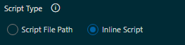

### APIM swagger JSON file

This JSON file is just a metadata for the APIM API’s.

### APIM API global policy xml file

This XML file contain the policy details like Ip filter, Cors etc.

### PowerShell Script

The PowerShell script created with the following commands,

1. New-AzApiManagementContext
2. Import-AzApiManagementApi
3. Set-AzApiManagementPolicy

Get-AzSubscription

$ApplyPocicy = $Env:IsPolicyUpdateEveryRelease

Write-Host "APIM service deployment started.."

$context = New-AzApiManagementContext -ResourceGroupName $(AzureResourceGroupName) -ServiceName $(AzureServiceName)

Write-Host "Importing APIM JSON file"

Import-AzApiManagementApi -Context $context -SpecificationPath "$(System.DefaultWorkingDirectory)/gc_dynamics_api/drop/DCIP_MISC/APIM/$(ApimJsonFileName)" -SpecificationFormat "OpenApi" -Path $(ApimApiPath) -ApiId $(ApimApiName) -ServiceUrl $(ApimApiServiceUrl)

Write-Host "Imported APIM JSON file successfully"

if ($ApplyPocicy -eq "yes")

{

Write-Host "Applying policy : $(ApimApiName)"

Set-AzApiManagementPolicy -Context $context -PolicyFilePath "$(System.DefaultWorkingDirectory)/gc_dynamics_api/drop/DCIP_MISC/APIM/$(ApimPolicyFileName)" -ApiId $(ApimApiName)

Write-Host "Policy applied successfully."

}

else

{

Write-Host "Skipping policy, value of IsPolicyUpdateEveryRelease found : $(IsPolicyUpdateEveryRelease)"

}

This pipeline satisfy flowing general scenarios,

## **Pipeline Variable details**

If the APIM API is not exist and you want to create new APIM API you need to provide valid variable value,

1. **ApimAPIName**: An user defined unique name.
2. **IsPolicyUpdateEveryRelease:** The value of this variable would be either yes/no. If the value will “**no”** then policy will not applied to the APIM API.
3. **ApimAPIPath:** Unique API path ex : DevEnv, TestEnv, etc
4. **ApimApiServiceUrl :** Internal service url for Azure app services
5. **ApinJsonFileName:** name of the swagger JSON file.
6. **ApimPolicyFileName:** Name of the policy XML file.

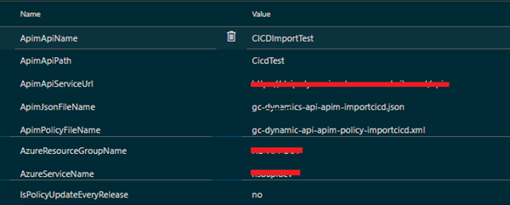

## **How to use the pipeline?**

### Create new APIM API

#### Create swagger JSON file

#### Create XML policy file

#### Commit the changes in the branch

#### Run the build pipeline **gc_dynamics_api**

#### Run the release pipeline to release the changes – This is automatically triggers.

### Update Existing APIM (Add new operation)

#### Update swagger JSON file (Add new operation in the file)

#### Update XML policy file (Add new policy in the file)

#### Commit the changes in the branch

#### Run the build pipeline gc_dynamics_api

#### Run the release pipeline to release the changes – This is automatically triggers.

### Update Existing APIM (Remove existing operation)

#### Update swagger JSON file (Remove new operation in the file)

#### Update XML policy file (Remove new policy in the file)

#### Commit the changes in the branch

#### Run the build pipeline gc_dynamics_api

#### Run the release pipeline to release the changes – This is automatically triggers.